GitHub Copilot Agent Workshop – Hands-on Challenges

Challenge 1: Incident (Ticket) Management System

Business Context
A support organization needs an Incident Management System to track issues with workflows, priorities, and ownership.

Functional Scope
- Create & manage incidents
- Workflow: open → in_progress → resolved → closed
- Priority: low | medium | high
- Assigned owner
- Full test coverage & documentation

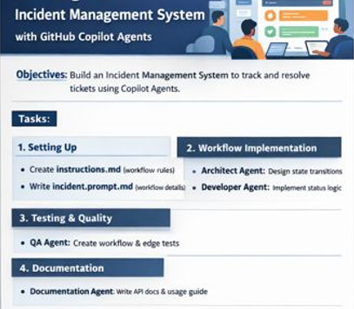
Project Structure
incident_app/
├── app/
│ ├── main.py
│ ├── database.py
│ ├── models/
│ ├── schemas/
│ ├── repositories/
│ ├── services/
│ ├── api/
│ └── core/
├── tests/
│ ├── unit/
│ └── integration/
├── docs/
├── instructions.md
└── prompts/

Task Split & Agent Usage

Task 1: Instruction File (Architect Agent – Agent Mode)
Define: - Workflow rules - Allowed status transitions - Layer boundaries

Task 2: Prompt Files (Developer Agent – Chat Mode)
Create prompts for: - Incident CRUD - Workflow enforcement - Exception handling

Task 3: Custom Agents (Agent Mode)
- Architect Agent
- Developer Agent
- QA Agent
- Documentation Agent

Task 4: Workflow Implementation (Developer Agent – Agent Mode)
- State transition logic
- Validation for invalid transitions
- Exception handling
Use Edit Mode for improvements.

Task 5: Testing Workflow (QA Agent – Agent Mode)
- Workflow-based test cases
- Negative & edge-case scenarios

Task 6: Documentation (Documentation Agent – Chat Mode)
- Workflow explanation
- API samples

Common Tech Stack (Your preferred stack)
- Language: Python 3.10+
- Framework: FastAPI
- Database: SQLite
- ORM: SQLAlchemy
- Validation: Pydantic
- Testing: Pytest
- Docs: OpenAPI (auto) + Markdown

